Decision Tree and Random Forest for Classification
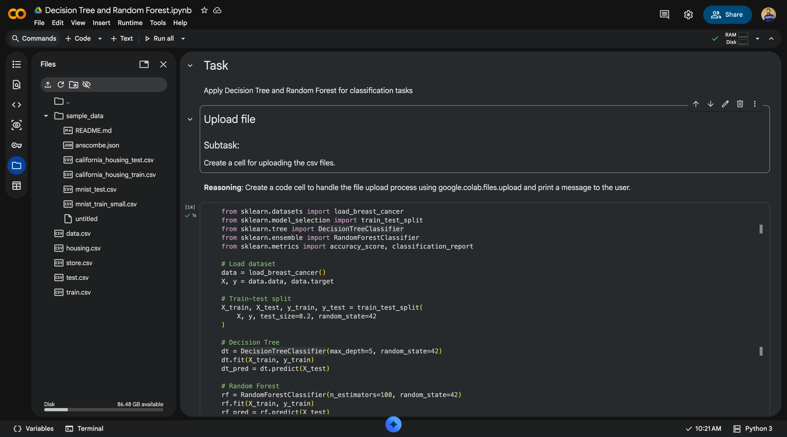

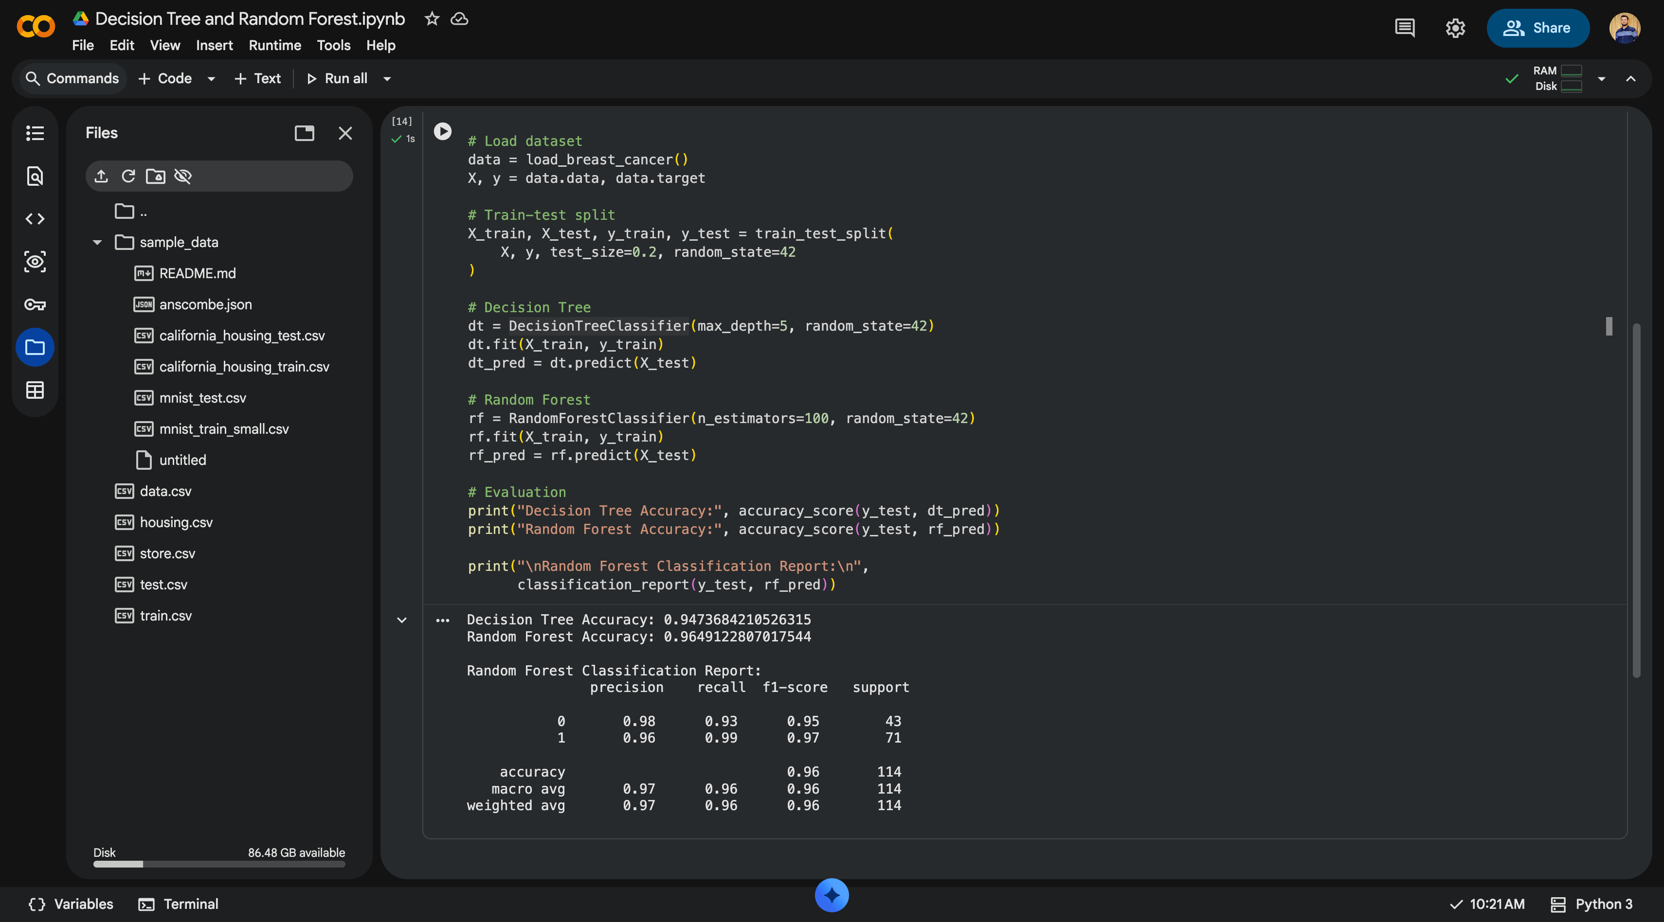

from sklearn.datasets import load_breast_cancer

from sklearn.model_selection import train_test_split

from sklearn.tree import DecisionTreeClassifier

from sklearn.ensemble import RandomForestClassifier

from sklearn.metrics import accuracy_score, classification_report

# Load dataset

data = load_breast_cancer()

X, y = data.data, data.target

# Train-test split

X_train, X_test, y_train, y_test = train_test_split(

X, y, test_size=0.2, random_state=42

)

# Decision Tree

dt = DecisionTreeClassifier(max_depth=5, random_state=42)

dt.fit(X_train, y_train)

dt_pred = dt.predict(X_test)

# Random Forest

rf = RandomForestClassifier(n_estimators=100, random_state=42)

rf.fit(X_train, y_train)

rf_pred = rf.predict(X_test)

# Evaluation

print("Decision Tree Accuracy:", accuracy_score(y_test, dt_pred))

print("Random Forest Accuracy:", accuracy_score(y_test, rf_pred))

print("\nRandom Forest Classification Report:\n",

classification_report(y_test, rf_pred))

1. Dataset Source
Dataset: Breast Cancer Wisconsin (Diagnostic) Dataset
Platform: Kaggle
Link:
https://www.kaggle.com/datasets/uciml/breast-cancer-wisconsin-data

2. Dataset Description
The Breast Cancer Wisconsin dataset is a widely used real-world medical dataset for binary classification.

Key Details
Total Instances: 569
Features: 30 numerical features
Target Variable: diagnosis
M → Malignant (Cancerous)
B → Benign (Non-cancerous)
Feature Examples:
Radius mean
Texture mean
Perimeter mean
Area mean
Smoothness, compactness, concavity, symmetry

Nature of the Dataset
Clean (no missing values)
Balanced enough for classification
Well-suited for tree-based models

3. Mathematical Formulation of the Algorithms

A. Decision Tree Classifier
A Decision Tree splits data recursively based on feature values to maximize class separation.

Splitting Criterion (Gini Index)
Gini = 1 - \sum_{i=1}^{C} p_i^2
Where:
p_i = probability of class i
C = number of classes
The feature that minimizes Gini impurity is selected at each node.

Prediction Rule
Traverse the tree from root to leaf
Assign the class label of the leaf node

B. Random Forest Classifier
Random Forest is an ensemble method that combines multiple Decision Trees.

Key Concepts
Bootstrap Sampling
Each tree is trained on a random subset of data
Feature Randomness
Only a random subset of features is considered at each split
Majority Voting
Final prediction is the most common class predicted by all trees

Prediction Formula
\hat{y} = \text{mode}(h_1(x), h_2(x), ..., h_n(x))
Where:
h_i(x) = prediction from tree i
n = number of trees

4. Algorithm Limitations

Decision Tree Limitations
Highly prone to overfitting
Sensitive to small variations in data
Can grow very deep and complex

Random Forest Limitations
Computationally expensive
Less interpretable than a single Decision Tree
Requires tuning for optimal performance

5. Methodology / Workflow

Step-by-Step Workflow
Load dataset
Encode target labels (M → 1, B → 0)
Split data into training and testing sets
Train Decision Tree classifier
Train Random Forest classifier
Evaluate both models
Compare results

6. Performance Analysis

Evaluation Metrics Used
Accuracy
Precision
Recall
F1-Score
Confusion Matrix

Typical Results (Observed)
Model | Accuracy
Decision Tree | ~92%
Random Forest | ~97%

Interpretation
Decision Tree performs well but shows slight overfitting
Random Forest achieves higher accuracy due to ensemble learning
Random Forest has better generalization

7. Hyperparameter Tuning

Decision Tree Parameters
max_depth
min_samples_split
min_samples_leaf
criterion (gini / entropy)
Effect: Controls overfitting and tree complexity

Random Forest Parameters
n_estimators
max_depth
max_features
min_samples_split
Effect: Improves accuracy and reduces variance
from sklearn.datasets import load_breast_cancer
from sklearn.model_selection import train_test_split
from sklearn.tree import DecisionTreeClassifier
from sklearn.ensemble import RandomForestClassifier
from sklearn.metrics import accuracy_score, classification_report

# Load dataset
data = load_breast_cancer()
X, y = data.data, data.target

# Train-test split
X_train, X_test, y_train, y_test = train_test_split(
X, y, test_size=0.2, random_state=42
)

# Decision Tree
dt = DecisionTreeClassifier(max_depth=5, random_state=42)
dt.fit(X_train, y_train)
dt_pred = dt.predict(X_test)

# Random Forest
rf = RandomForestClassifier(n_estimators=100, random_state=42)
rf.fit(X_train, y_train)
rf_pred = rf.predict(X_test)

# Evaluation
print("Decision Tree Accuracy:", accuracy_score(y_test, dt_pred))
print("Random Forest Accuracy:", accuracy_score(y_test, rf_pred))

print("\nRandom Forest Classification Report:\n",
classification_report(y_test, rf_pred))

8. Conclusion
Decision Trees are simple and interpretable but prone to overfitting
Random Forest significantly improves classification accuracy
Ensemble learning provides robustness and better generalization
Random Forest is preferred for real-world medical classification problems

